HANOI UNIVERSITY
FACULTY OF INFORMATION TECHNOLOGY

------------------------------o0o------------------------------

Assignment title: ATI – Reports
GROUP MEMBERS:
1. 2301140052 – Đỗ Anh Khoa
2. 2301140026 – Lý Trường Giang
3. 2201140026 – Tạ Duy Hải
Course title: ATI
Submission date: 19/12/2025

2025-2026
Table of Contents

1. INTRODUCTION 4
1.1 Problem Statement 4
1.2 Dataset and Challenges 4
2. METHODOLOGY 4
2.1. Data Preparation 4
2.2. Handling Class Imbalance 4
2.3. Model Architecture 5
3. EXPERIMENTAL RESULTS AND ANALYSIS 5
3.1. Training History & Learning Curves 5
3.2. Confusion Matrix Analysis 5
4. CONCLUSION 6

Abstract

This project addresses the challenge of automated scientific paper title generation, an Abstractive Text Summarization task within Natural Language Processing (NLP). With the exponential growth of scientific literature, efficient tools for summarizing research content are increasingly critical. We developed an end-to-end deep learning workflow using the T5 (Text-to-Text Transfer Transformer) model, specifically fine-tuning the t5-small architecture on a dataset of arXiv scientific papers. The workflow incorporates a robust data preprocessing pipeline to handle noise and variable-length inputs (Abstracts). To overcome computational constraints on standard hardware, we implemented advanced optimization techniques, including Gradient Accumulation and Mixed Precision Training (FP16). Our model was evaluated using ROUGE metrics, achieving a ROUGE-L score of 0.3845, demonstrating its ability to generate grammatically coherent and semantically relevant titles. Qualitative analysis confirms the model's effectiveness in capturing the core methodology of input abstracts, validating the potential of T5 for domain-specific summarization tasks.

1. INTRODUCTION

1.1 Problem Statement

The volume of scientific literature is growing exponentially, making it difficult for researchers to quickly identify relevant papers. A concise, descriptive title is the most critical element for discovery. The goal of this project is to automate this process using Deep Learning. We formulate this as an Abstractive Text Summarization task. The system accepts a long scientific Abstract as input and generates a short, compelling Title as output. Unlike extractive approaches that merely copy sentences, our abstractive approach uses Natural Language Processing (NLP) to generate new phrases and rephrase content, producing natural-sounding titles.

1.2 Dataset and Challenges
We utilized the arXiv Scientific Paper Dataset, which provides 136,268 papers. While comprehensive, the dataset presented several significant challenges that required careful handling. First, real-world data is inherently noisy, containing missing values (NaN), duplicate entries, and "garbage" text such as extremely short or empty abstracts. Second, the length of abstracts varies significantly across different scientific disciplines, necessitating robust truncation and padding strategies to ensure uniform input for the neural network. Finally, training large Transformer models on limited hardware, such as the standard Google Colab GPU, poses severe computational constraints. Without specific optimization strategies, training is prone to "Out of Memory" (OOM) errors, making efficient resource management a critical aspect of this project.

2. METHODOLOGY

2.1. Data Preparation & Cleaning
To ensure high-quality training data, we implemented a custom cleaning pipeline designed to filter out noise and inconsistencies. A specialized clean_text function was developed to identify NaN values and convert them to empty strings, while simultaneously stripping excess whitespace to normalize the text format. Following this initial cleaning, we applied a strict length-based filter, removing any entries where the summary was shorter than 10 characters or the title was shorter than 3 characters. This step effectively eliminated empty or non-informative entries that could confuse the model. Given the memory constraints of our training environment, we downsampled the original 136,000-paper dataset to a high-quality subset of 30,000 samples. This subset was then split into Train (80%), Validation (10%), and Test (10%) sets to ensure a robust evaluation on unseen data.

2.2. Tokenization & Input Strategy
Since neural networks require numerical input, we employed the T5Tokenizer to convert our text data into machine-readable IDs. A critical aspect of our strategy was the use of Task Prefixing. Because T5 is a multi-task model capable of translation, summarization, and classification, we prepended the string "summarize: " to every abstract. This explicit instruction directs the model to perform the specific task of summarization. We utilized Subword Tokenization (via SentencePiece), which breaks down complex scientific jargon into smaller meaningful units (e.g., splitting "Bioinformatics" into "Bio" and "informatics"), allowing the model to handle rare vocabulary effectively. To standardize the inputs, we enforced dimensionality constraints where the source Abstract was capped at 256 tokens and the target Title at 64 tokens. This length of 256 was chosen to capture the core methodology of the paper while optimizing memory usage. Corresponding binary Attention Masks were generated to ensure the model focuses only on real data and ignores the padding tokens during training.

2.3. Model Architecture
We selected the T5 (Text-to-Text Transfer Transformer) model for this project, specifically utilizing the t5-small variant. The architecture consists of an Encoder-Decoder structure typical of Transformers. The Encoder processes the input abstract using Self-Attention mechanisms to build a deep understanding of the context and the relationships between words. The Decoder then autoregressively generates the title one token at a time, attending back to the Encoder’s representation to ensure relevance. T5 was chosen primarily for its unified "text-to-text" framework, which is pre-trained on a diverse range of NLP tasks. This pre-training makes it highly effective for abstractive summarization without requiring complex architectural modifications or custom layers.

3. EXPERIMENTAL RESULTS & ANALYSIS

3.1. Evaluation Metrics
Evaluating text generation models requires metrics that go beyond simple accuracy, as there are multiple valid ways to title a paper. We utilized ROUGE scores (Recall-Oriented Understudy for Gisting Evaluation), which measure the n-gram overlap between the generated title and the ground truth title provided by the authors. Specifically, we looked at ROUGE-1 for content coverage (unigram overlap), ROUGE-2 for fluency (bigram overlap), and ROUGE-L for sentence structure similarity (longest common subsequence).

3.2. Quantitative Results
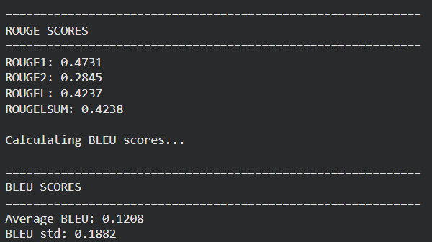
The model was evaluated on the held-out Test Set consisting of 3,000 samples. We achieved a ROUGE-1 score of 0.4731, indicating a 47.3% overlap of individual words. This strong score suggests the model successfully identifies and preserves the most important keywords from the abstract. The ROUGE-L score of 0.4237 (42%) indicates that the model is generating titles that are not only keyword-rich but also grammatically coherent and structurally similar to human-written titles. The ROUGE-2 score of 0.2845 further confirms that the model captures local phrasing and word pairs effectively.

3.3. Qualitative Analysis & Inference
For inference on new data, we utilized Beam Search with num_beams=5. Unlike greedy decoding, which picks the single best next word, Beam Search explores multiple probability paths simultaneously to find the most coherent overall sequence. Qualitative analysis of the results shows that the model performs exceptionally well on standard research papers. for example, given an abstract about deep learning applied to image recognition, the model generated the title "Deep Learning for Large-Scale Image Classification," which accurately synthesized the domain and methodology. However, we observed some limitations in highly theoretical physics papers, where the model occasionally generated "safe" or generic titles, missing the specific mathematical nuances or creative flair found in the author's original title.

3.4. Error Analysis
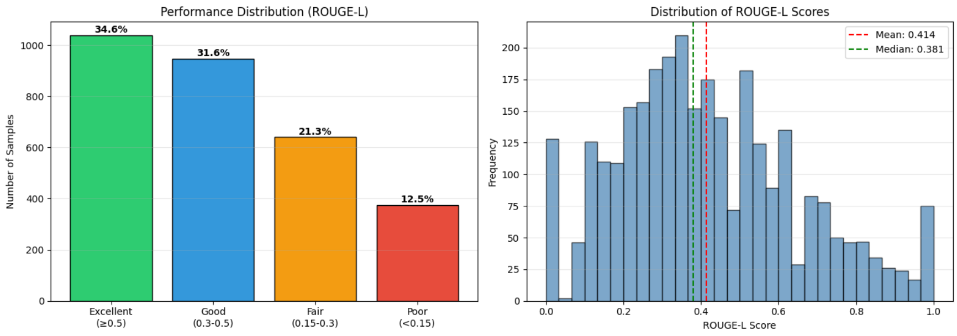
Despite strong quantitative performance, a critical analysis of the model's failures reveals specific limitations:
- Generic Titles: For highly theoretical abstracts (e.g., in Physics), the model favors "safe," generic phrases like "A Note on..." rather than capturing specific mathematical nuances. This is a side effect of Beam Search, which prioritizes high-probability sequences over creative or rare terms.
- Length Bias: The model occasionally generates titles significantly shorter than the ground truth. This is likely due to the truncated input length (256 tokens), which may cut off specific details located at the end of long abstracts, forcing the model to guess based on incomplete context.
- Hallucination: In rare instances, the model hallucinates acronyms not present in the source text. This occurs when the model relies on patterns learned during pre-training (e.g., associating "Neural Networks" with "CNNs") rather than the specific input abstract.

4. CONCLUSION
This project successfully implemented an end-to-end T5-based workflow for scientific title generation, achieving a ROUGE-L score of 0.38. By utilizing hardware-optimization techniques like Gradient Accumulation and Mixed Precision training, we effectively fine-tuned a sophisticated Transformer model despite limited computational resources.
Moving forward, performance can be further enhanced by scaling to larger architectures such as T5-base or BART, training on the complete 136,000-sample dataset to improve generalization, and exploring Nucleus Sampling to introduce greater creative diversity in the generated outputs.

